**Department Invited Speakers Do Not Reflect**

**Trainee Diversity**

Running title: Invited Speaker Diversity Does Not Reflect Trainee Diversity

Ada K. Hagan, Ph.D.1*†*, Rebecca M. Pollet, Ph.D.1, and Josie Libertucci, Ph.D.2*†*

*†* To whom correspondence should be addressed: akhagan@umich.edu or libertj@mcmaster.ca

1. Department of Microbiology & Immunology, University of Michigan, Ann Arbor, Michigan
2. Department of Medicine, McMaster University, Hamilton, Ontario, Canada

Figures: 1

Tables: 1

1. **Abstract**
2. **Keywords**
3. inclusion, diversity, invited speakers, academia, graduate programs

# 4 Background

1. Long-standing systemic bias, sexism, and racism have contributed to the underrepresentation of many
2. racial and ethnic groups, as well as women, in science, technology, engineering, and math (STEM) fields
3. (NIH 2015 report, Measuring DEI 2016, (1)). Organizational climate and culture that supports inclusion of
4. all individuals is essential to support the retention of historically underrepresented minorities (HURM) in
5. the U.S., as well as non-Caucasian individuals, and women in STEM fields (Schneider, 2013). Inclusive
6. organizational culture will not suffice in retaining HURM, non-Caucasian individuals, and women without 11 organization policy changes that support their values and goals (2).
7. A long-standing issue within STEM fields, specifically within academia, has been a lack of diverse
8. representation of scientists for trainees (graduate students and postdoctoral fellows). In order to maintain
9. retention of HURM, non-Caucasian individuals, and women in STEM fields, it is important for trainees to
10. have visual representations of themselves as scientists. The importance of representation in retaining a
11. diverse group of individuals in STEM fields is supported by social role theory (3). Individuals tend to make
12. inferences about characteristics that are needed to be successful in a given role by examining individuals
13. that most occupy that role (3, 4). Therefore, trainees who do not see representation of themselves in senior
14. scientific positions, or in this case as senior faculty members, may decide that they do not possess the
15. characteristics that are required to succeed. In an attempt to make science a more inclusive environment,
16. many individuals have attempted to address this issue by promoting the inclusion of more women speakers 22 at conferences (5–7). However, no study to date has addressed invited speaker seminar series diversity 23 within their own institution.
17. Within the Department of Microbiology and Immunology at the University of Michigan (Ann Arbor, MI, USA),
18. each year from September to June, faculty members have the opportunity to invite scientists from other
19. institutions to give a one-hour seminar in which all department members attend. The invited seminar
20. speaker also has the opportunity to meet with current department faculty members and trainees. Scientists
21. who are invited to give seminars are widely regarded as successful and the top in their field. Thus, if
22. trainees are constantly being exposed to “the top scientist in their field”, according to social role theory, it is 30 imperative that the selected seminar speakers represent a diverse group of individuals.
23. In this study, we examine and compare the proportion of HURM, non-Caucasian/non-HURM, and women
24. invited speakers to white males in the Department of Microbiology and Immunology. Additionally, we
25. compare invited-speaker demographics to the current trainee demographics as a means to gauge if 34 trainee demographics are being represented accordingly throughout the seminar series. Following our
26. investigation, we proposed a policy change to the Department of Microbiology and Immunology in how
27. invited speakers are selected as a means to promote inclusion in our department and reduce stereotype
28. threat, microaggressions, and unconscious bias. In order to facilitate inviting a more diverse group
29. of scientists, we developed a set of resources that allow scientists, within the field of microbiology, to
30. self-identify as an HURM, non-Caucasian/non-HURM, or a woman. These resources will promote inclusion
31. and diversity by providing greater representation of all scientists and will provide hosts an opportunity to 41 invite a more diverse group of scientists.

# 42 Methods

43 Each academic year, each faculty member in the Department of Microbiology and Immunology at the 44 University of Michigan has the opportunity to invite one speaker per year for the department seminar series.

1. Some of these seminar slots are dedicated to named lectureships, which are decided by committee, and
2. three trainee-invited speakers. We analyzed the demographics of invited speakers and faculty hosts for five

academic years (Fall 2014 - Spring 2019), and compared their demographics to current trainees. Current trainees were defined as any graduate student or postdoctoral fellow within the department at the point of data analysis (Spring 2019). Each speaker was only counted once and department faculty members who invited the speaker were defined as “hosts”. The list of faculty hosts was used as a proxy for faculty demographics since as hosts, these faculty members are visible

representatives of the department. The trainee lists were obtained from department listservs that included 52 masters students, doctoral students, and post-doctoral fellows.

1. This is a retrospective study, thus individuals were not asked for their identities. Instead we hand-coded
2. proxy demographics using personal knowledge, photos, and CVs. The presenting gender of each individual
3. was assigned using a binary system (man/woman). Due to the low number of individuals in the study,
4. race/ethnicity demographics were split in three groups: Caucasian, Historically Under-represented Minority
5. (HURM), and Non-Caucasian/Non-HURM (NCNH), each with a binary (yes/no) possibility. Caucasian was
6. assigned using the current U.S. Census definition where those of Middle Eastern, European, and Russian
7. descent are included. HURM individuals were restricted to those with African-American, Indigenous, 60 Alaskan/Hawaian Native, Latinx and/or Hispanic heritage. All others were placed into the NCNH group.
8. We recognize that our proxy demographics are a limitation of the analysis and want to acknowledge that
9. the presenting gender may not reflect the gender(s) that an individual identifies as. We also want to
10. acknowledge that there are many other identities that are not captured in this limited analysis.
11. Data were analyzed and figures generated in R Statistical Software, using relevant packages (8–20).

# 65 Results

1. To understand the representation of women, we compared the proportion of women in each academic role.
2. At the trainee level, more than half of students and postdoctoral fellows were women. Women composed
3. 46.77% of faculty hosts and 38.73% of the invited speakers (Fig. 1A). Of 27 lectureships over the five
4. year period, 37.04% were awarded to women. The proportion of women as faculty hosts and speakers is
5. equivalent to global estimates that 40% of microbiologists are women, with a slightly lower representation 71 of women in lectureships (21).
6. Our analysis identified an over-representation of Caucasian individuals as hosting faculty and invited
7. speakers (80% each), relative to the proportion of Caucasian trainees, which was 55% (Fig. 1B). We also
8. observed declines in the representation of HURM and NCNH faculty and speakers relative to current trainees
9. (Fig 1B). HURM trainees made up 11% of the department, on track with the 11% of microbiology and

immunology doctorates awarded in 2017 (22). However, only 8.5% of invited speakers were HURM scientists. No faculty member was defined as a HURM scientist. NCNH trainees were 34% of department students and postdocs

1. (22% of microbiology and immunology doctorates in 2017), but only 19% of hosting faculty and 10.5% of 79 invited speakers (22).
2. The more prestigious invited speaker lectureships were also dominated by Caucasian scientists, who
3. comprised 81.48% of those awarded (Fig. 1C). HURM and NCNH scientists were awarded 3 and 2
4. lectureships, respectively. Because the intersection of identities can compound biases and outcomes,
5. we further examined the lectureships by gender and race/ethnicity status. Caucasian men and women
6. accounted for 44.44% and 37.04% of the lectureships, respectively. Only 18.52% of lectureships were held 85 by non-Caucasian men while none were held by non-Caucasian women (Fig. 1D).

# 86 Discussion

1. Several papers have investigated the representation of women at scientific conferences, however, we have
2. only identified one that focused on invited speakers at universities (23). In their study, Nittrouer et al,
3. examined 3,652 talks at 50 U.S. institutions in 2013 - 2014 and found that women faculty are less likely to
4. be invited speakers, despite similar acceptance rates. These results suggest that women faculty are less 91 often invited as speakers, a decision that may be negatively impacted by assumptions about competency
5. and dedication. The dedication of women who have children to their work is perceived to be less than
6. that of their colleagues, i.e., men who also have children. The perceived prioritization and commitments of
7. women to family over work may cause faculty to doubt their acceptance of a speaking invitation (despite
8. the prestigious nature of these invitations and evidence to the contrary)(**???**, 23). As a result, the faculty
9. member invites a different colleague who they feel is more likely to agree (and is a man). Departments have
10. different processes and criteria for selecting invited speakers, but it is a matter of pride to bring the best
11. scientists possible. It may be that the definition of “best” poses a problem to women, who need three-times
12. as many publications as their men colleges to be considered equally competent. Some departments only
13. invite tenured faculty, which severely limits the number of potential women speakers. Another scenario
14. is that pre-tenure faculty members invite prestigious, tenured faculty in their field to network and secure
15. letters for their own tenure package. The increased burden of women to prove competency decreases their 103 likelihood to be considered for either tenure or as possible source of tenure letters.

104 The desire to invite the “best” scientist to these seminar series also poses a problem for HURM and 105 NCNH scientists. A large portion of the NCNH cohort in our sample are Asian/Asian American individuals.

106 Although Asian scientists are well-represented in the US scientific workforce, they face significant bias 107 and barriers to inclusion in society and academia (24, 25). Both men and women who identify as HURM 108 and Asian reported having to work harder than white men to be perceived as legitimate scholars (26).

1. This expectation of higher productivity may result in fewer HURM and NCNH individuals being invited as
2. seminar speakers. This is particularly striking in the low number of NCNH individuals in the more prestigious 111 lectureships of our sample despite the higher employment rate of Asian scientists.

112 While HURM and NCNH share some experiences, differences including varying rates of hiring and tenure 113 promotion mean unique considerations are important for inclusion of each group (doi:10.1001/jama.284.

1. 9.1085). For instance, the proportion of HURM faculty at the Assistant and Associate Professor level is
2. currently higher than the Full Professor level so it will be difficult to increase speaker diversity if early-career
3. researchers are not being considered (27). Increased performance expectations and patterns of exclusions
4. are consistent themes in studies characterizing the HURM faculty experience (28, 29). Therefore, inclusion
5. of HURM faculty in seminar series is likely essential to increasing the number of HURM Associate and
6. Full Professors. More significantly, a major barrier to inclusion of HURM faculty at similar proportions to
7. HURM trainees is the low transition rate of scientists from HURM backgrounds to faculty positions and the
8. associated low proportion of HURM faculty (30). Even when HURM speaker rates match the proportion of
9. HURM faculty employment, HURM trainees will be represented at a significantly higher proportion. Inclusion 123 of HURM faculty in these seminarseries is just one aspect of larger institutional change that is needed (31).
10. We have not been able to identify any other publications examining scientific speaker diversity beyond
11. gender. This seems to be the first. This is concerning since conclusions drawn from gender-based studies
12. are often framed, and considered, to be applicable to other marginalized groups (e.g., HURM). This is
13. a flawed assumption. While there is no doubt some overlap, each group remains marginalized due to
14. a unique complex set of factors that cannot always be solved by gender-based solutions. US-serving
15. institutions, such as the University of Michigan have a particular responsibility to the historically suppressed 130 populations included in our definition of HURMs. We therefore implore US institutions to apply this framing 131 to their discussions and research.

132 According to social role theory, this department is not adequietly serving their non-Caucasian trainees. 133 Implict biases that affect perceptions of marginalized groups are the primary issue, but we must 134 acknowledge that it is not always possible to identify members of historically under-served communities.

1. For instance, after data analysis, we learned that at least one speaker in our data set should have been
2. categorized as a HURM instead of Caucasian, but it wasn’t readily apparent from their internet presence
3. or CV. This limitation makes two important points: that percieved identity often plays a larger role than 138 self-identification, and that we need better tools to identify members of marginalized groups.

# 139 Instituting policy change within the Department of Microbiology and Immunology

1. In an attempt to promote inclusion within the Dept. M&I these data were presented to faculty members and
2. the dept chair (Harry Mobley). Since, trainee demographics were not represented within seminar speaker
3. demographics over the past 5 years, we proposed a policy change as to how seminar speakers were being
4. invited. This policy change included switching from PI invited to lab invited in an attempt to allow trainees
5. to choose a speaker that best represented themselves. In addition to this we also created resources which 145 allowed scientists to self-identify and provide host faculty with more diverse choices.

# 146 Building Diversify

1. To help address this issue, we make some suggestions (Table 1) and have developed a resource to identify
2. scientists who are members of marginalized and/or historically under-served groups. Motivated by a lack
3. of such resources and inspired by similar resources–DiversifyEEB and DiversifyChemistry–we created 150 DiversifyMicrobiology and DiversifyImmunology. These resources are a tool for symposium organziers, 151 award committees, search committees and other scientists to identify individuals to diversify their pools.

152 Additionally, we have built these as a tool for use by other fields and organizations to create their own 153 lists. Importantly, since these lists are compiled by self-nomination, we can ensure that only scientists 154 comfortable revealing their marginalized identities are included.

1. The self-nomination form is a Google Form with entries logged in a private Google Sheet. This form is
2. embedded within the website and can be linked to directly. The use of a Google Forms allows us to
3. maintain this database at no cost and gives us the flexibility to add questions or change response options 158 without disrupting previous responses. Entries are logged in a private spreadsheet so that entries can 159 be screened before being added to the public database. This screening currently includes two steps: 1.
4. Confirming that each person is listed in the database only once. 2. Verifying that the submitted website is a
5. professional website for the person being listed. If a person has not been listed in the database previously
6. and passes step 2, a new entry is added to the public database spreadsheet. If a person is already listed 163 in the database, their information is updated to the most recent submission.
7. This public spreadsheet is embedded in the website and can be open separately as a locked (uneditable)
8. Google Sheet. Importantly, this allows the list to be easily searched. We have chosen to list individuals’
9. academic information first in the spreadsheet to encourage a focus on academic achievement rather than
10. tokenization of marginalized identities. Currently the database lists individuals in order of self-nomination
11. but future versions will be re-sorted based on name and/or academic field to varying the individuals who 169 may receive more attention for simply being at the top of the list.
12. The website provides an interface to the Google forms and spreadsheets with template pages for viewing
13. the list, adding a name to the list, and finding additional resources. Importantly, our website creation tool
14. is hosted for free by GitHub, which provides a free website for each GitHub organization. Basic tools and
15. skills required to set up a Diversify site include knowledge of, or experience with, the version control tool git, 174 the webtool GitHub, and a text editor. A tutorial in the DiversifyMicrobiology repository on GitHub provides 175 links to these resources and instructions for adapting the tool to your own field.

# 176 Conclusion

1. To increase the retention of white women and HURMS in STEM, they must also be represented as experts.
2. However, the invited speaker diversity at one department does not represent the diversity of trainees. There 179 is a lack of research on invited speakers examining factors other than gender. To facilite the identification

180 and recruitment of individuals in these historically under-served groups, we have built a tool to create 181 self-nominated, field-specific lists.

# 182 Acknowledgements

1. We thank Drs. Beth Moore and Harry Mobley and the Department of Microbiology & Immunology, University
2. of Michigan for their input and financial support that enabled publication of our manuscript. We would also 185 like to acknowledge Nick Lesniak and Dr. Ariangela Kozick for their comments and suggestions.

# 186 Author Contributions

1. A.K.H. collected the data, assigned demographics, analyzed the data, and created the website. R.M.P.
2. created the Google lists, forms, and website content and the description of their maintenance. J.L. wrote 189 the introduction, provided conceptual advice, and facilitated the policy change to the Department of Microbiology and Immunology with A.K.H. All authors contributed to preparing the final manuscript.

# 190 Code and data availability

1. The anonymized data, code for all analysis steps, and an Rmarkdown version of this manuscript is available
2. at [https://github.com/akhagan/Hagan_SpeakerDiversity_XXXX_2019/.](https://github.com/akhagan/Hagan_SpeakerDiversity_XXXX_2019/) Template and complete instructions
3. for generating a field-specific Diversity website are available at [https://github.com/diversifymicrobiology/](https://github.com/diversifymicrobiology/DiversifyMicrobiology.github.io/)
4. [DiversifyMicrobiology.github.io/.](https://github.com/diversifymicrobiology/DiversifyMicrobiology.github.io/)

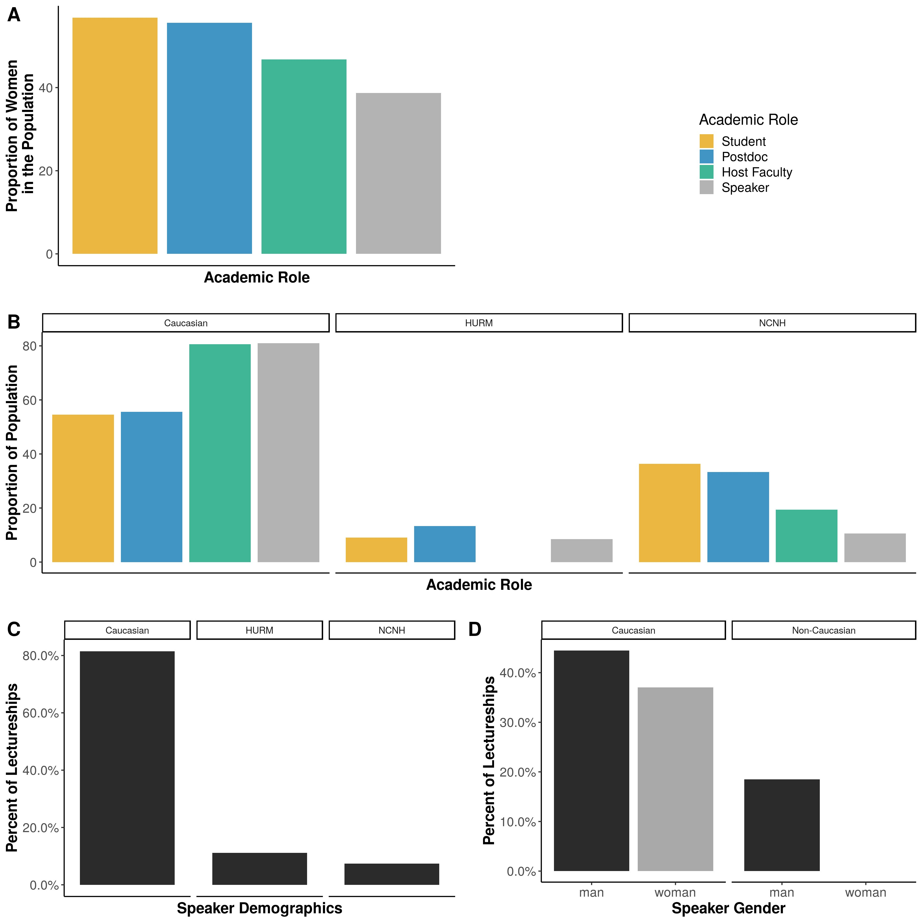

Figure 1: **The demographics of invited speakers, hosting faculty, and trainees.** A) The proportion of women in each academic role. B) The proportion of each academic role represented by individuals that are Caucasian (left), Historically Underrepresented Minorities (HURM, center) or International (right). C-D)The percent of lectureships awarded to individuals that are C) Caucasian, HURM, International or D) Caucasian or Non-Caucasian by gender.

1. Table 1: List of suggestions and resources to increase invited speaker diversity.

|  |  |  |
| --- | --- | --- |
| **Suggestion** | **Description** | **Resource** |
| Lab-invited speakers | Faculty members can request suggestions from trainees |  |
| Use a list | Many lists of scientists from under-represented and underserved groups are available | https://DiversifyMicrobiology.  github.io/resources |
| Create a list | Use the GitHub template create a self-nomination list and resource for your field | https://github.com/diversifymicrobiology/  DiversifyMicrobiology.github.io |
| Highlight the journey | Invite all speakers to spend a few moments describing their personal science journey |  |

196

# 197 References

198 1. 2012. Colloquy on minority males in science, technology, engineering, and mathematics. National 199 Academies Press.

200 2. **Coe IR**, **Wiley R**, **Bekker L-G**. 2019. Organisational best practices towards gender equality in science 201 and medicine. The Lancet **393**:587–593. doi[:10.1016/s0140-6736(18)33188-x.](https://doi.org/10.1016/s0140-6736(18)33188-x)

202 3. **Eagly AH**, **Steffen VJ**. 1984. Gender stereotypes stem from the distribution of women and men into 203 social roles. Journal of Personality and Social Psychology **46**:735–754. doi[:10.1037/0022-3514.46.4.735.](https://doi.org/10.1037/0022-3514.46.4.735)

204 4. **Carter AJ**, **Croft A**, **Lukas D**, **Sandstrom GM**. 2018. Women’s visibility in academic seminars: Women 205 ask fewer questions than men. PLOS ONE **13**:e0202743. doi[:10.1371/journal.pone.0202743.](https://doi.org/10.1371/journal.pone.0202743)

206 5. **Kalejta RF**, **Palmenberg AC**. 2017. Gender Parity Trends for Invited Speakers at Four Prominent 207 Virology Conference Series. Journal of Virology **91**. doi[:10.1128/JVI.00739-17.](https://doi.org/10.1128/JVI.00739-17)

208 6. **Casadevall A**, **Handelsman J**. 2014. The Presence of Female Conveners Correlates with a Higher 209 Proportion of Female Speakers at Scientific Symposia. mBio **5**. doi[:10.1128/mBio.00846-13.](https://doi.org/10.1128/mBio.00846-13)

1. 7. **Klein RS**, **Voskuhl R**, **Segal BM**, **Dittel BN**, **Lane TE**, **Bethea JR**, **Carson MJ**, **Colton C**, **Rosi S**,
2. **Anderson A**, **Piccio L**, **Goverman JM**, **Benveniste EN**, **Brown MA**, **Tiwari-Woodruff SK**, **Harris TH**,
3. **Cross AH**. 2017. Speaking out about gender imbalance in invited speakers improves diversity. Nature 213 Immunology **18**:475–478. doi[:10.1038/ni.3707.](https://doi.org/10.1038/ni.3707)

214 8. **R Core Team**. 2017. R: A language and environment for statistical computing. R Foundation for 215 Statistical Computing, Vienna, Austria.

1. 9. **Wickham H**. 2017. Tidyverse: Easily Install and Load the ’Tidyverse’.
2. 10. **Wilke CO**. 2019. Cowplot: Streamlined plot theme and plot annotations for ’ggplot2’.
3. 11. **Allaire J**, **Horner J**, **Xie Y**, **Marti V**, **Porte N**. 2018. Markdown: ’Markdown’ rendering for r.
4. 12. **Xie Y**, **Allaire J**, **Grolemund G**. 2018. R markdown: The definitive guide. Chapman; Hall/CRC, Boca 220 Raton, Florida.

221 13. **Allaire J**, **Xie Y**, **McPherson J**, **Luraschi J**, **Ushey K**, **Atkins A**, **Wickham H**, **Cheng J**, **Chang W**, 222 **Iannone R**. 2018. Rmarkdown: Dynamic documents for r.

223 14. **Xie Y**. 2014. Knitr: A comprehensive tool for reproducible research in R. *In* Stodden, V, Leisch, F, Peng, 224 RD (eds.), Implementing reproducible computational research. Chapman; Hall/CRC.

1. 15. **Xie Y**. 2018. Knitr: A general-purpose package for dynamic report generation in r.
2. 16. **Grolemund G**, **Wickham H**. 2011. Dates and times made easy with lubridate. Journal of Statistical 227 Software **40**:1–25.
3. 17. **Wickham H**, **Bryan J**. 2018. Readxl: Read excel files.
4. 18. **Ooms J**. 2019. Pdftools: Text extraction, rendering and converting of pdf documents.
5. 19. **Wickham H**. 2018. Scales: Scale Functions for Visualization.
6. 20. **Neuwirth E**. 2014. RColorBrewer: ColorBrewer Palettes.
7. 21. **Allagnat L**, **Berghmans S**, **Falk-Krzesinski HJ**, **Hanafi S**, **Herbert R**, **Huggett S**, **Tobin S**. 2017. 233 Gender in the global research landscape.

234 22. **Science and Engineering Statistics NC for**. 2017. Survey of Doctorate Recipients, Survey Year 235 2017. National Science Foundation, Alexandria, VA.

1. 23. **Nittrouer CL**, **Hebl MR**, **Ashburn-Nardo L**, **Trump-Steele RCE**, **Lane DM**, **Valian V**. 2018. Gender
2. disparities in colloquium speakers at top universities. Proceedings of the National Academy of Sciences 238 **115**:104–108. doi[:10.1073/pnas.1708414115.](https://doi.org/10.1073/pnas.1708414115)

239 24. **Hwang W-C**, **Goto S**. 2008. The impact of perceived racial discrimination on the mental health of 240 asian american and latino college students. Cultural Diversity and Ethnic Minority Psychology **14**:326–335. 241 doi[:10.1037/1099-9809.14.4.326.](https://doi.org/10.1037/1099-9809.14.4.326)

242 25. **Tran VC**, **Lee J**, **Huang TJ**. 2019. Revisiting the asian second-generation advantage. Ethnic and 243 Racial Studies **42**:2248–2269. doi[:10.1080/01419870.2019.1579920.](https://doi.org/10.1080/01419870.2019.1579920)

244 26. 2013. Seeking Solutions: Maximizing American Talent by Advancing Women of Color in Academia: 245 Summary of a Conference. National Academies Press, Washington, D.C.

1. 27. **Whittaker JA**, **Montgomery BL**, **Martinez Acosta VG**. 2015. Retention of Underrepresented Minority
2. Faculty: Strategic Initiatives for Institutional Value Proposition Based on Perspectives from a Range of 248 Academic Institutions. Journal of undergraduate neuroscience education: JUNE: a publication of FUN, 249 Faculty for Undergraduate Neuroscience **13**:A136–145.

250 28. **Pololi L**, **Cooper LA**, **Carr P**. 2010. Race, Disadvantage and Faculty Experiences in Academic 251 Medicine. Journal of General Internal Medicine **25**:1363–1369. doi[:10.1007/s11606-010-1478-7.](https://doi.org/10.1007/s11606-010-1478-7)

1. 29. **Hassouneh D**, **Lutz KF**, **Beckett AK**, **Junkins EP**, **Horton LL**. 2014. The experiences of
2. underrepresented minority faculty in schools of medicine. Medical Education Online **19**:24768. 254 doi[:10.3402/meo.v19.24768.](https://doi.org/10.3402/meo.v19.24768)
3. 30. **Gibbs KD**, **Basson J**, **Xierali IM**, **Broniatowski DA**. 2016. Decoupling of the minority PhD talent
4. pool and assistant professor hiring in medical school basic science departments in the US. eLife **5**. 257 doi[:10.7554/elife.21393.](https://doi.org/10.7554/elife.21393)
5. 31. **Johnson MDL**. 2019. mSphere of Influence: Hiring of Underrepresented Minority Assistant
6. Professors in Medical School Basic Science Departments Has a Long Way To Go. mSphere **4**.
7. doi[:10.1128/mSphere.00599-19.](https://doi.org/10.1128/mSphere.00599-19)